OAM INSTALLATION

Unzip the SW

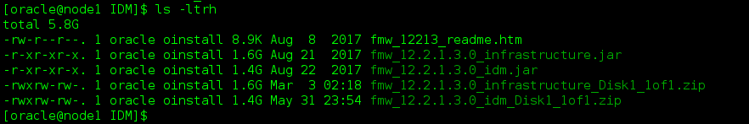

Install FMW in silent mode

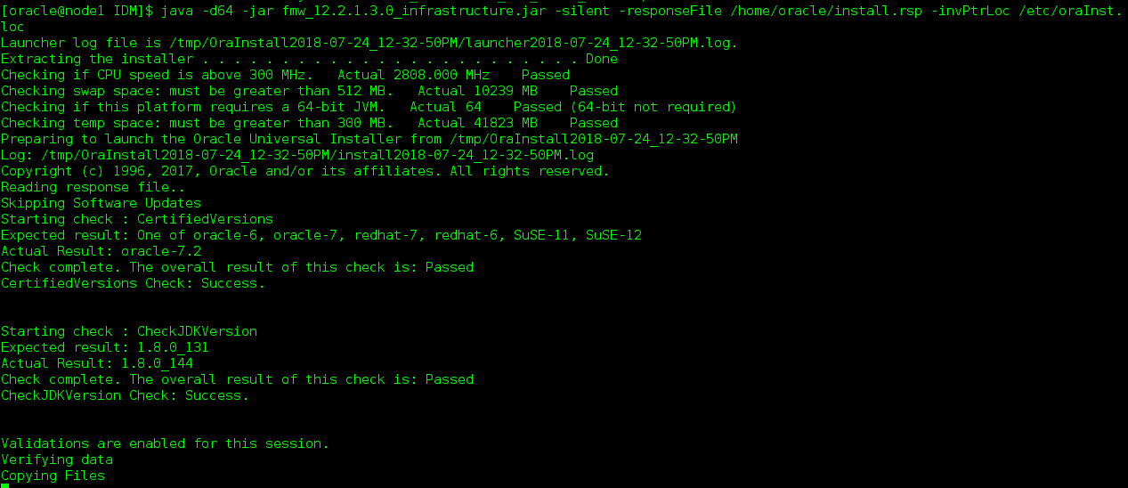

Install.rsp file

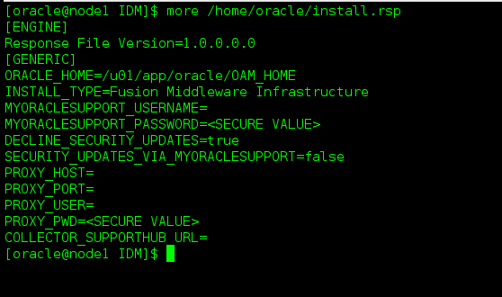

FMW is installed in below location

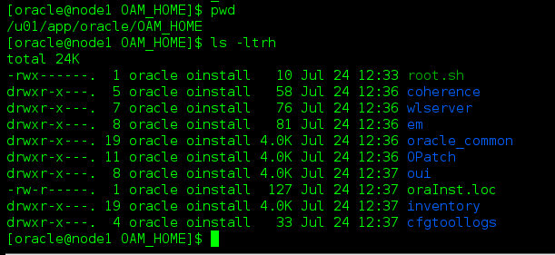

Install OAM software

Unzip the SW



Launch OAM

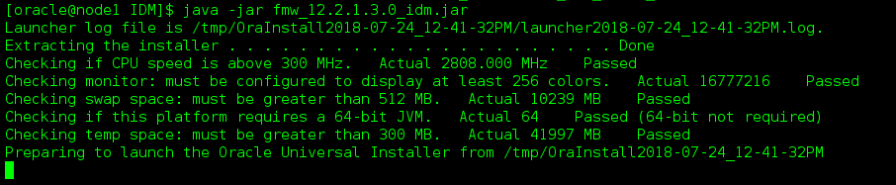

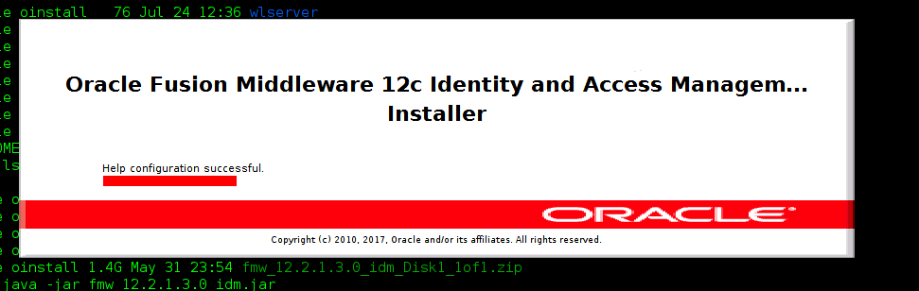

Click on next

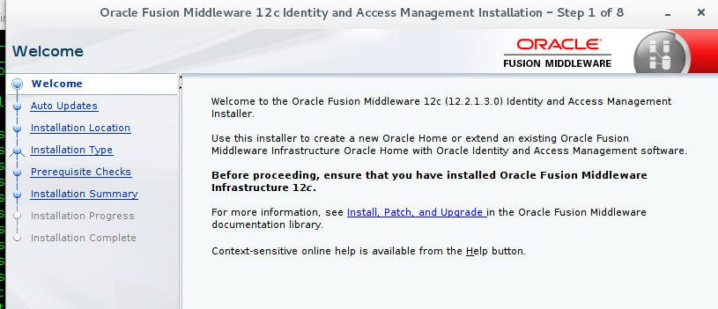

Skip Auto updates

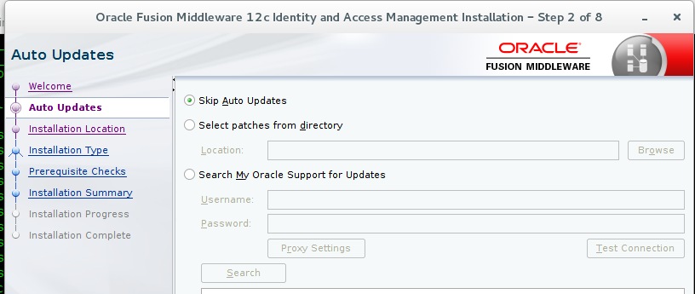

MW home location

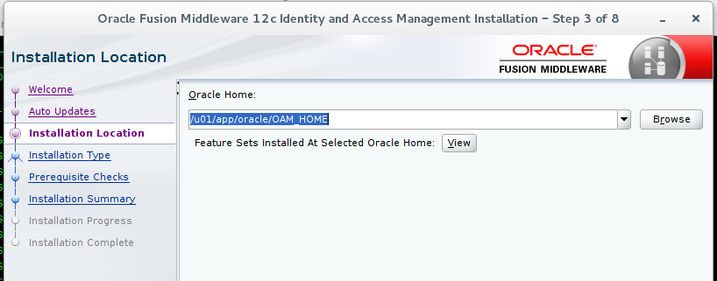

Collocated Mode

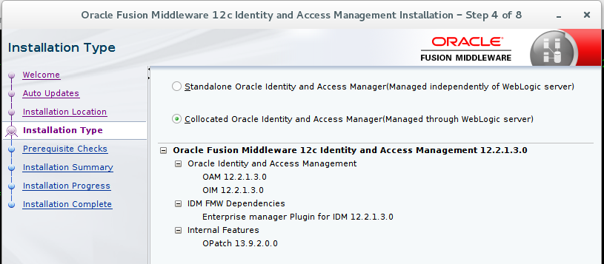

Installation completed successfully

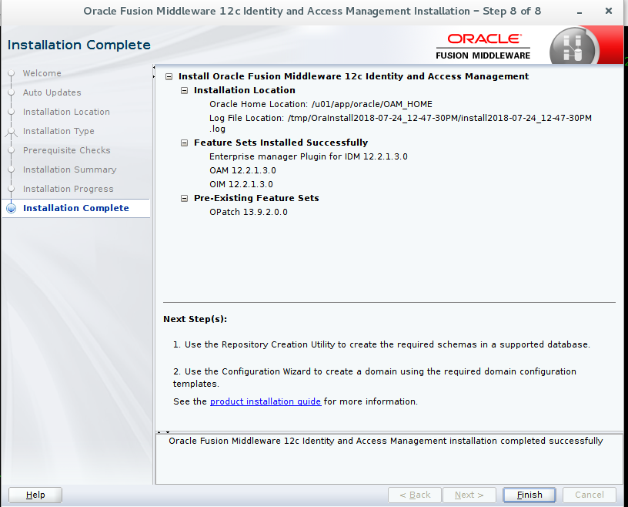

OAM and IDM binaries

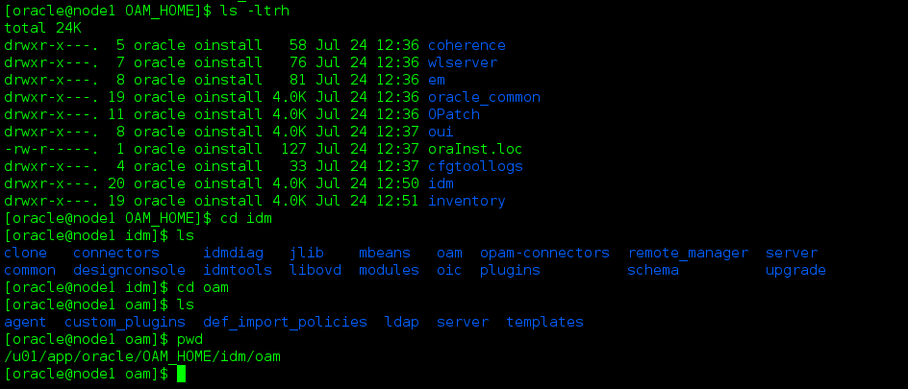

Install OHS

Unzip the Sw

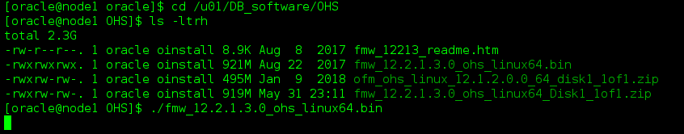

Launch OHS

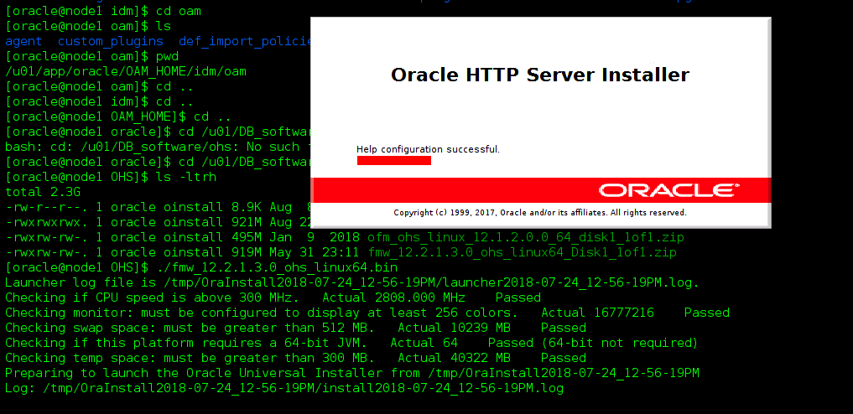

Click Next

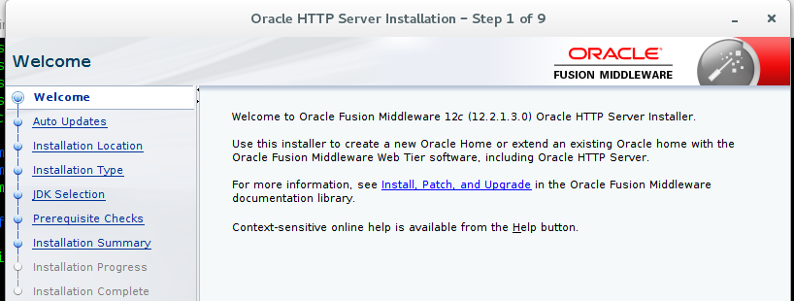

Skip Auto updates

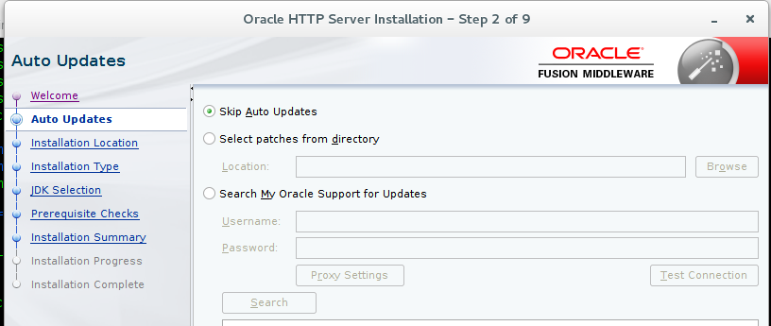

MW home

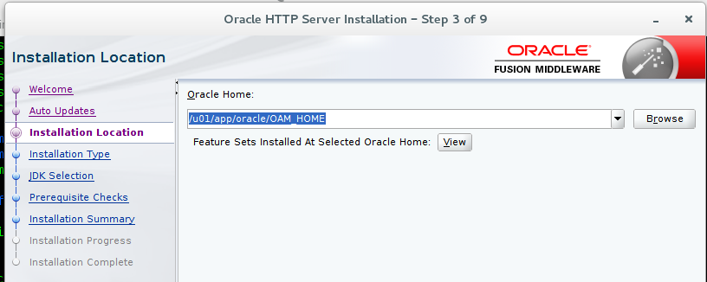

Collocated mode

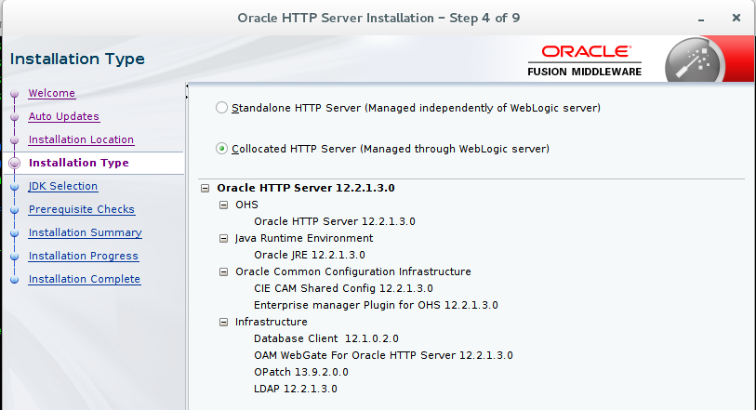

JDK home

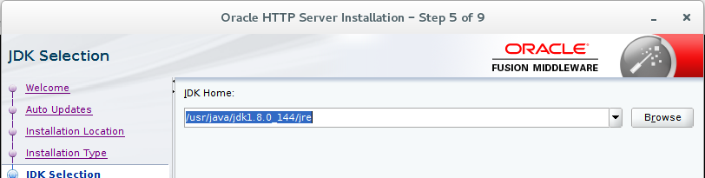

Installation Summary

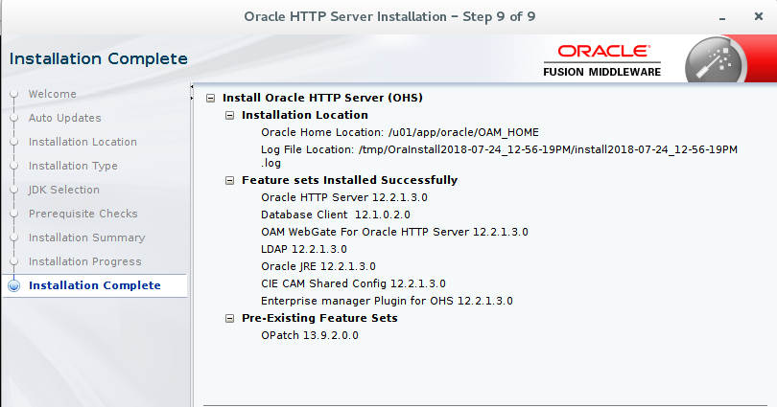

Location of OHS

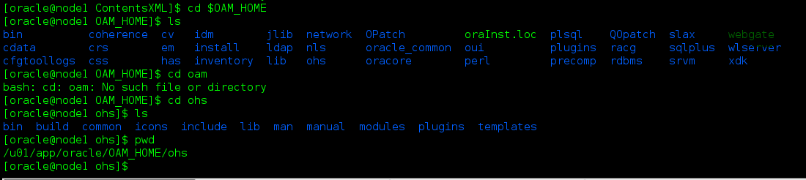

Install OUD

Unzip the SW

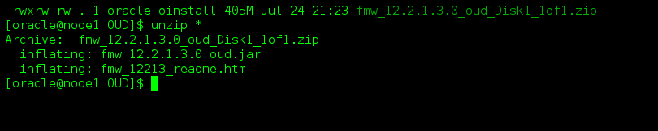

Launch OUD

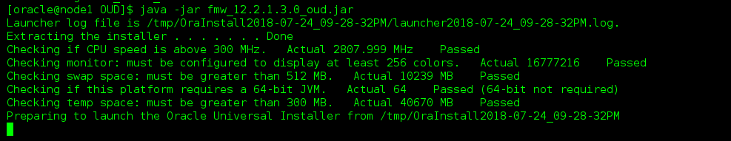

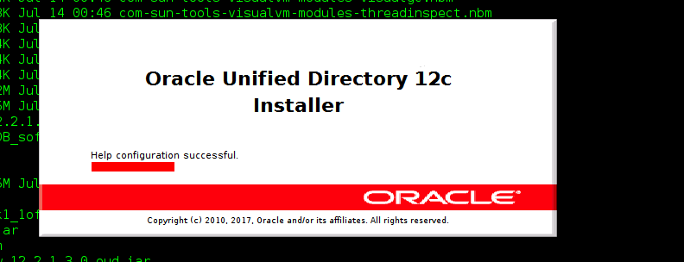

Click Next

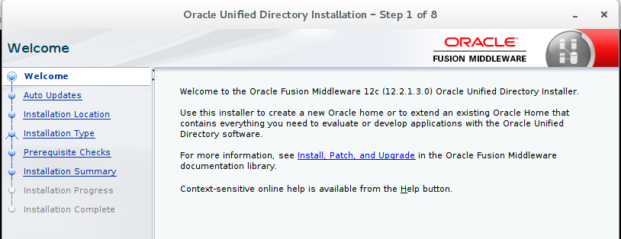

Skip Auto updates

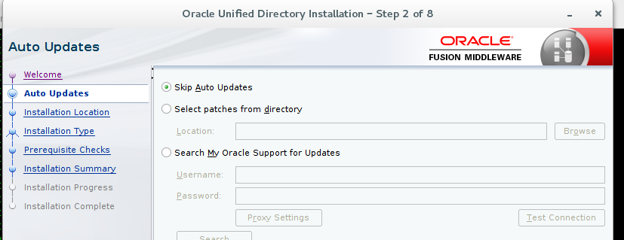

MW Home Location

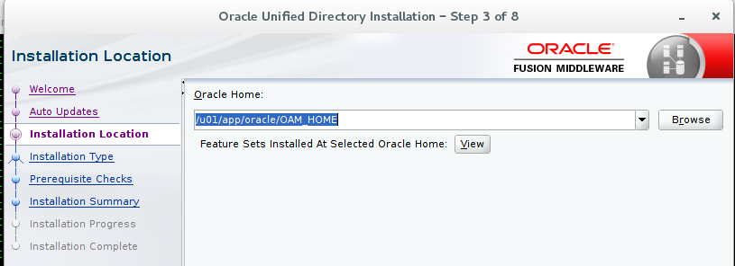

Collocated mode

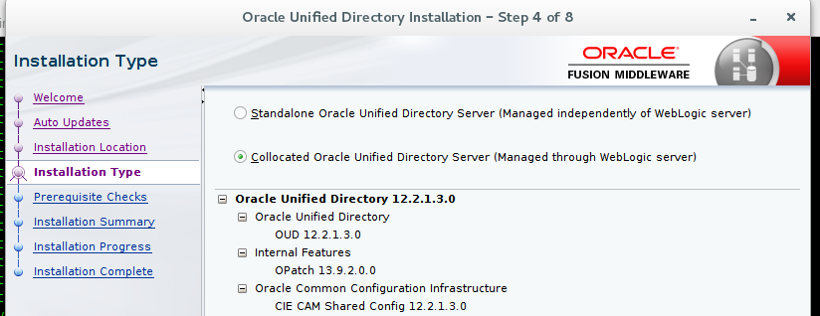

Installation Complete

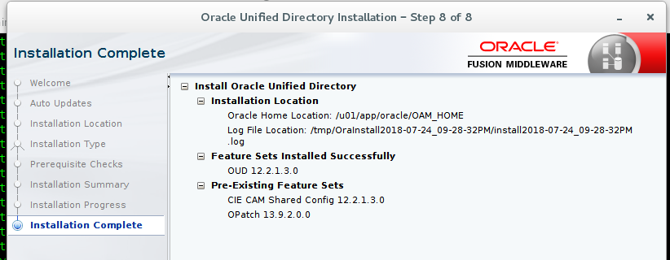

OUD Installed Location

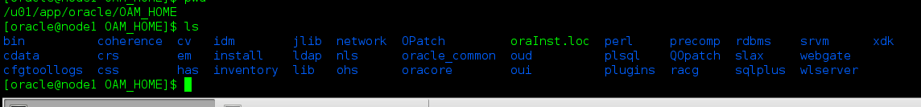

Create RCU for OAM, OUD, OHS

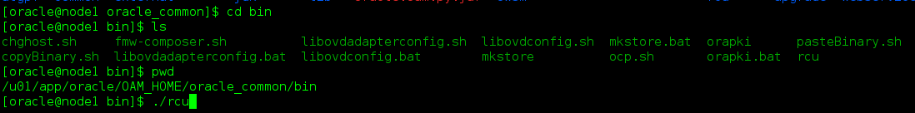

Welcome

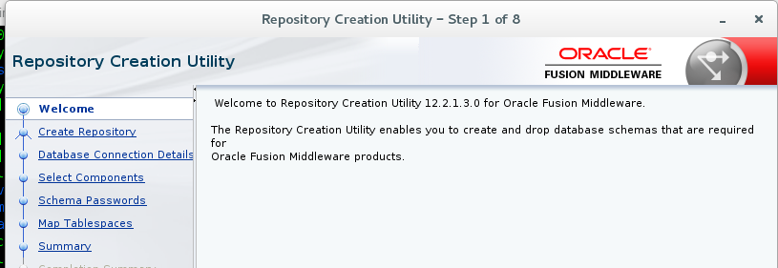

Create repository

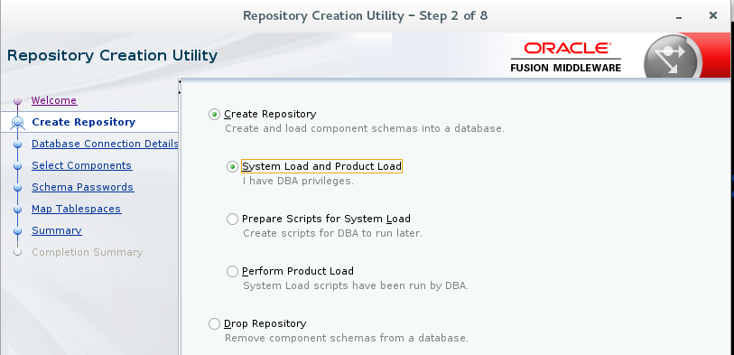

DB connection details

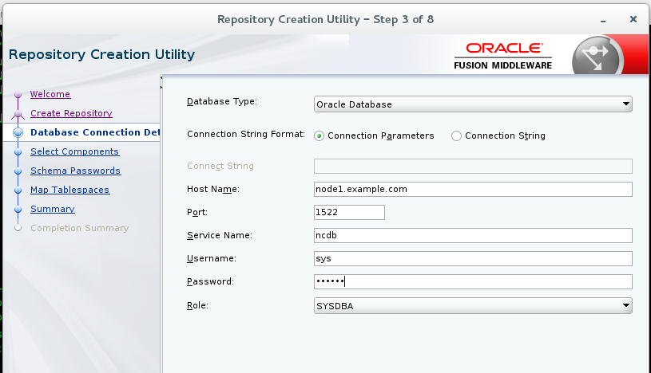

Select components

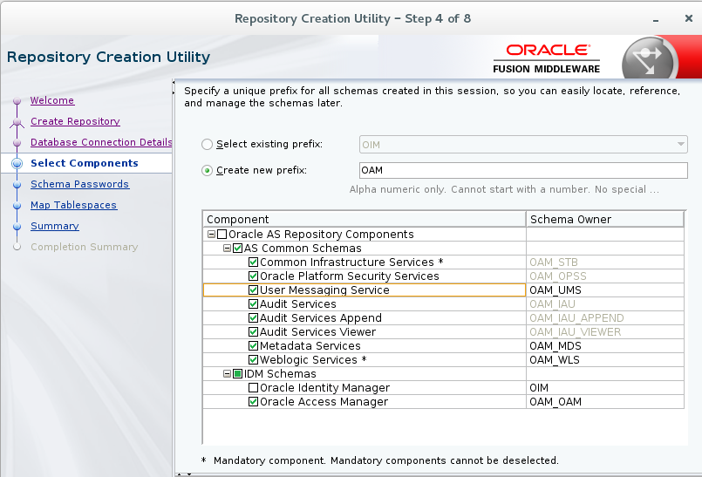

Choose Passwords

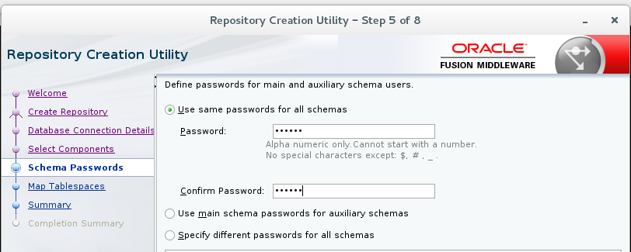

Summary

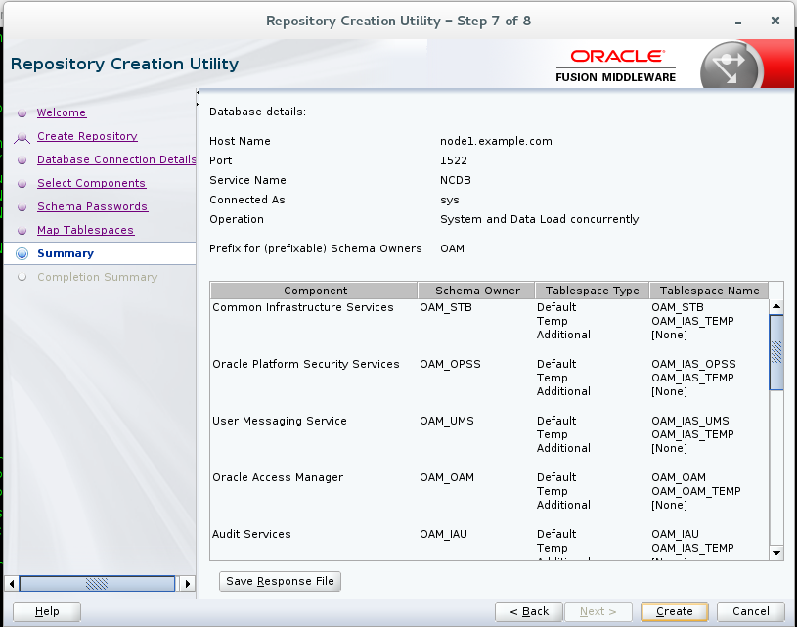

Creating a domain for OAM

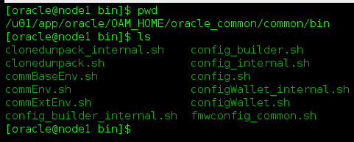

Launch config.sh

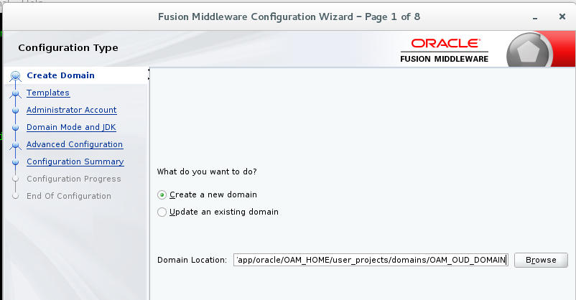

Select component

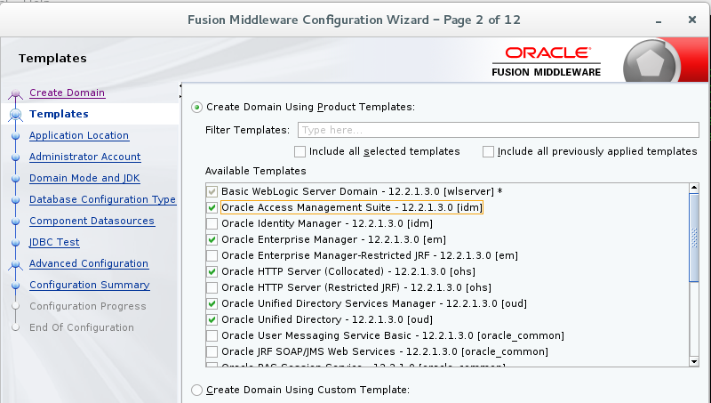

APP location

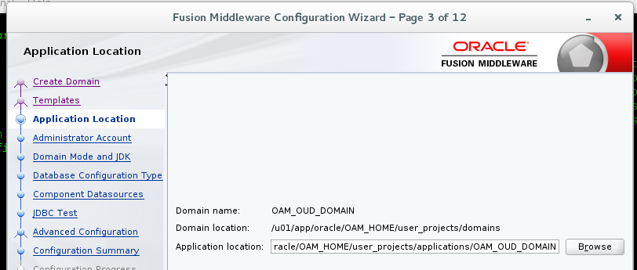

Admin Acc

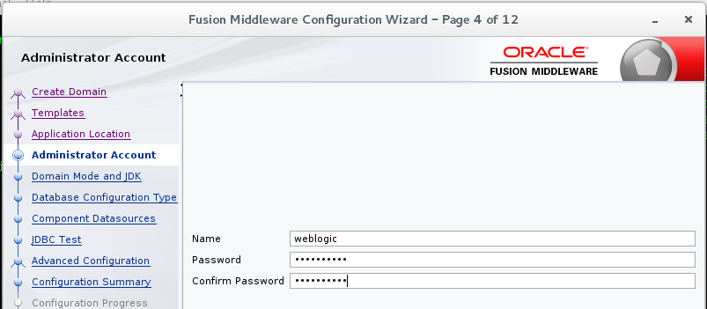

Dev mode

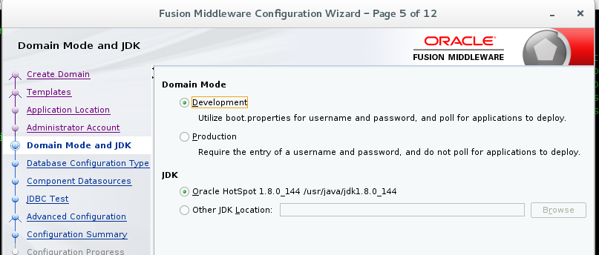

RCU information

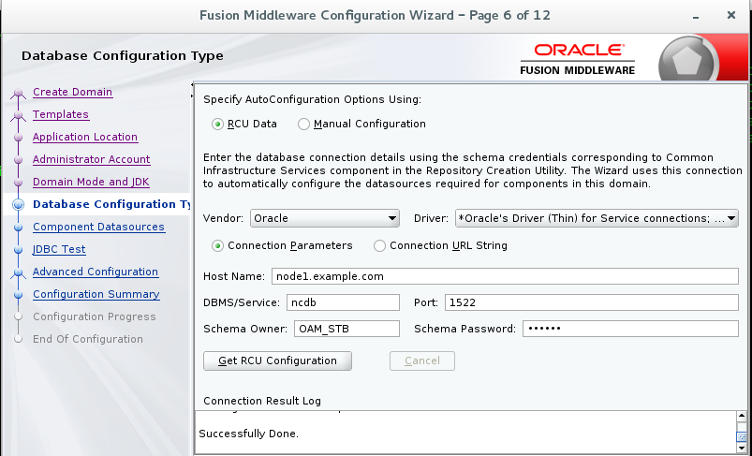

Component information

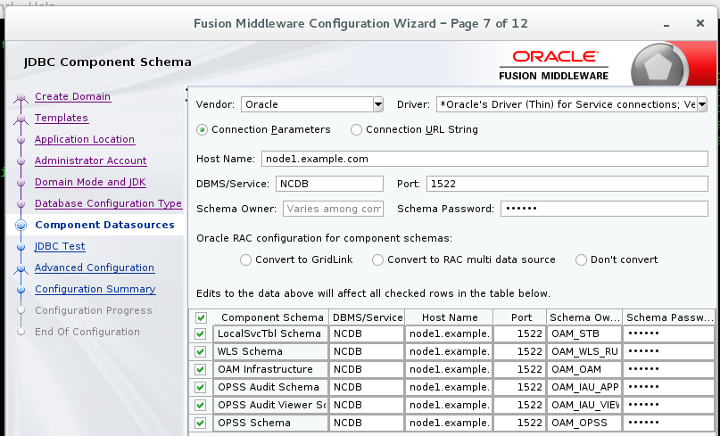

JDBC TEST

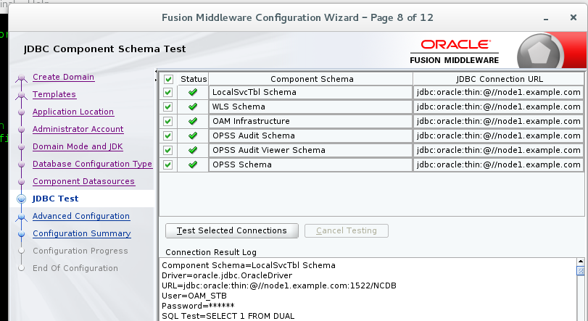

Advanced configuration

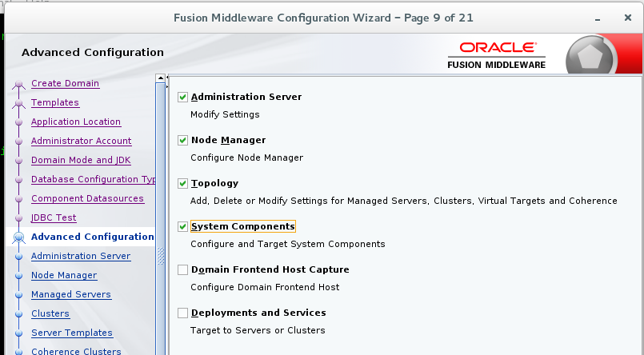

Admin Server Port details

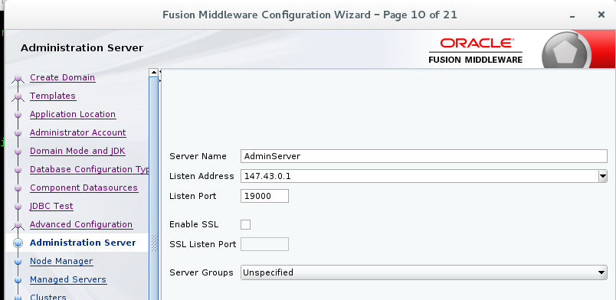

NM Manager Location

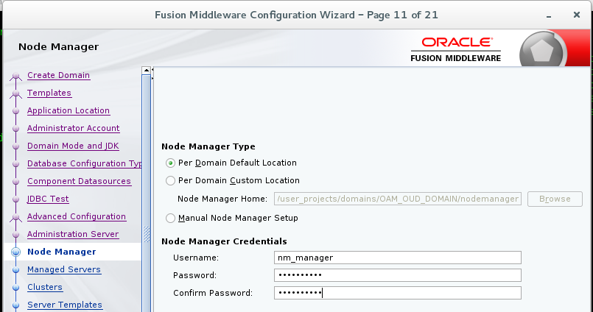

MS server details

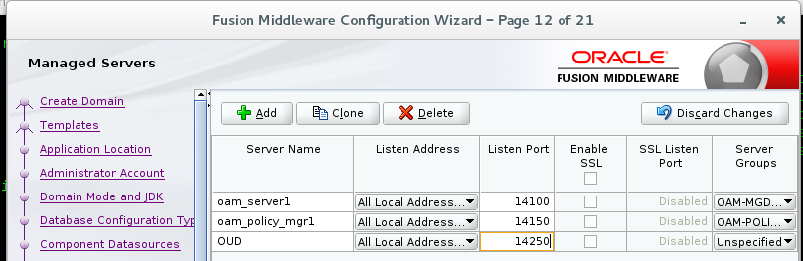

Machine details

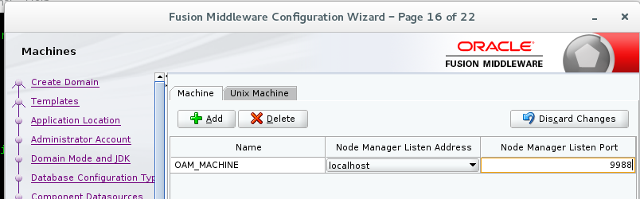

Assign Servers to Machines

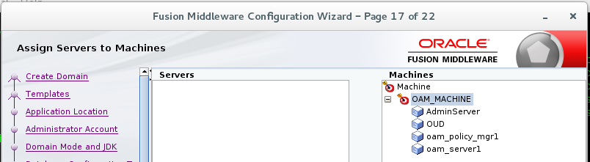

System component information for OHS and OUD

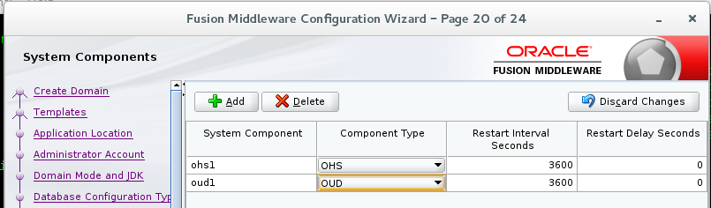

OHS Server details

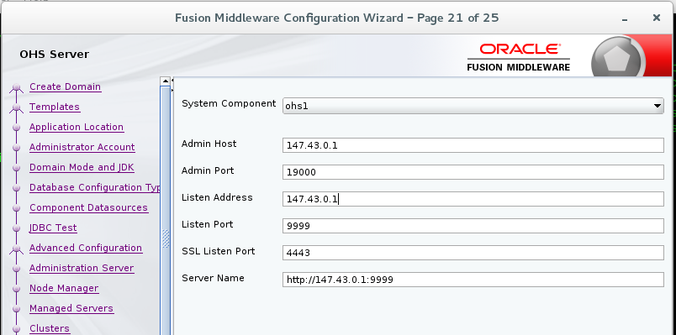

Assign System component to machines

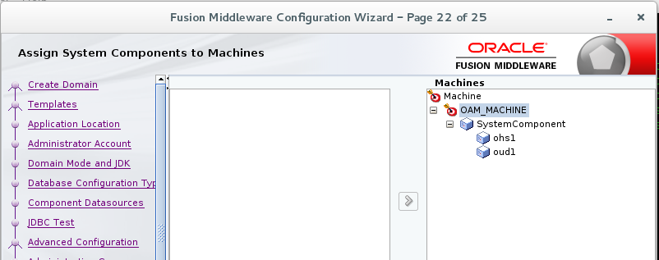

Configuration summary

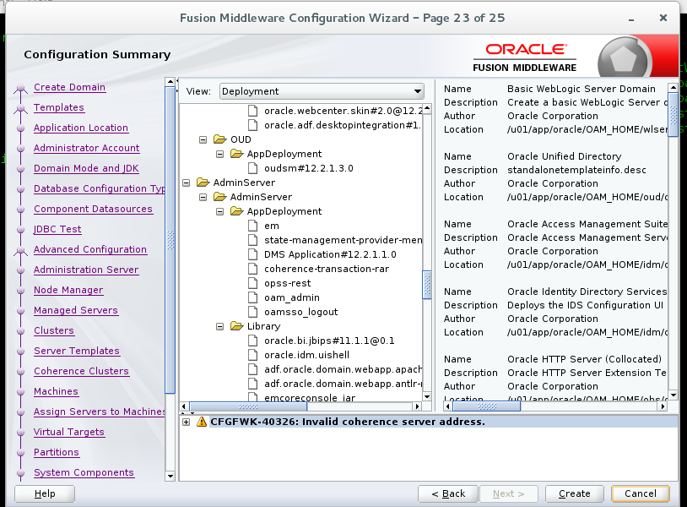

Installation summary

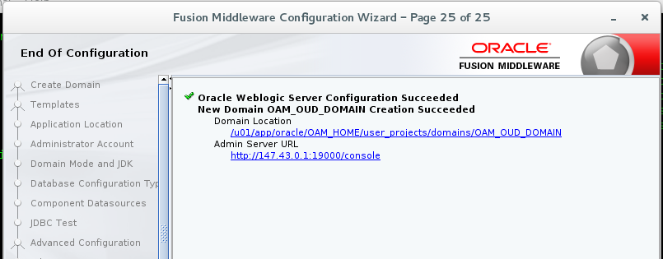

Start Node Manager

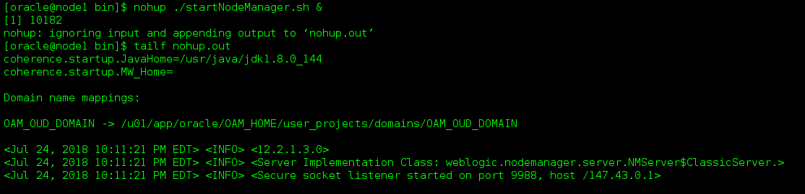

Start Weblogic.sh



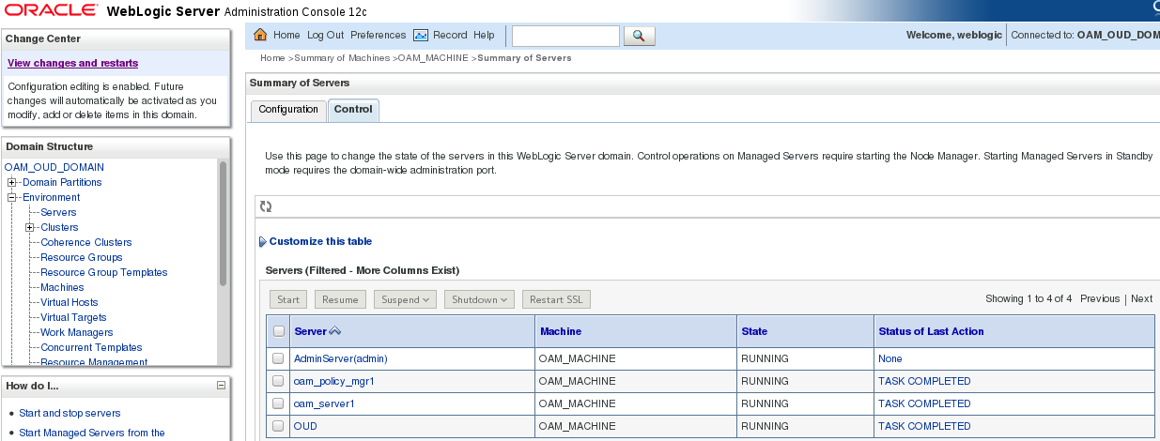

OAM Console

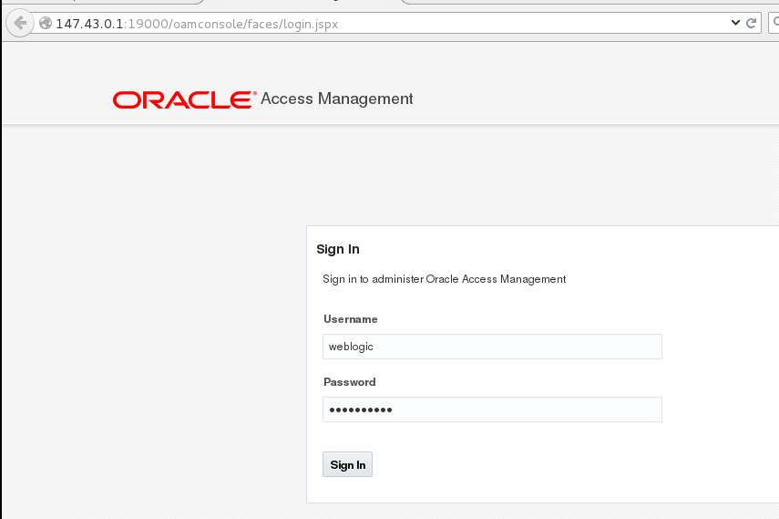

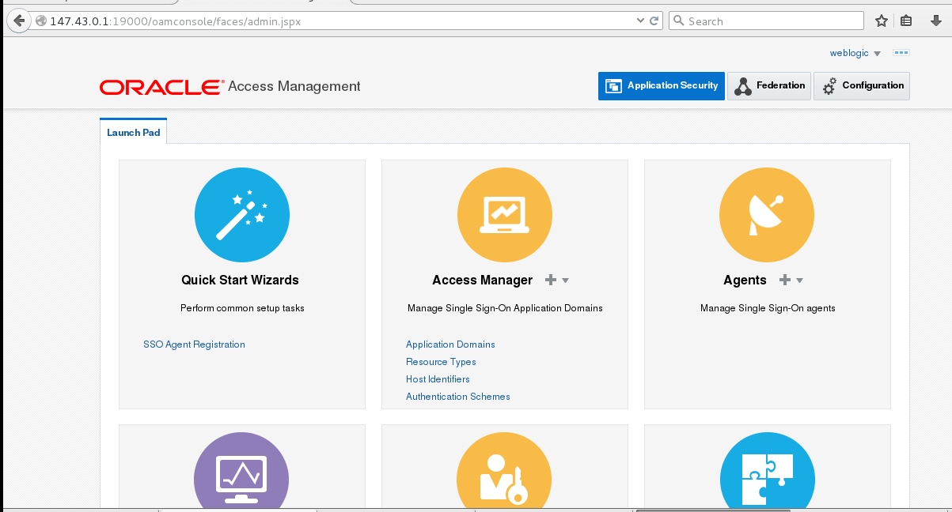

You can also access OAM console from oam_policy_mgr1 MS port( 11g2PS3 feature)

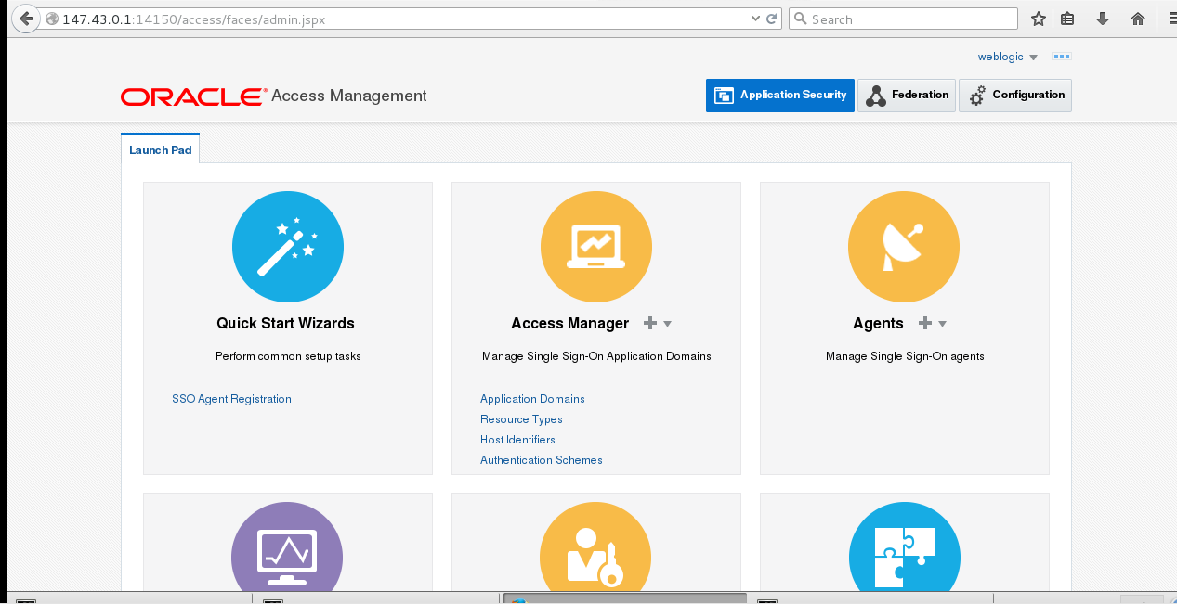

Start OHS( node manager should always be in SSL mode to start OHS1)

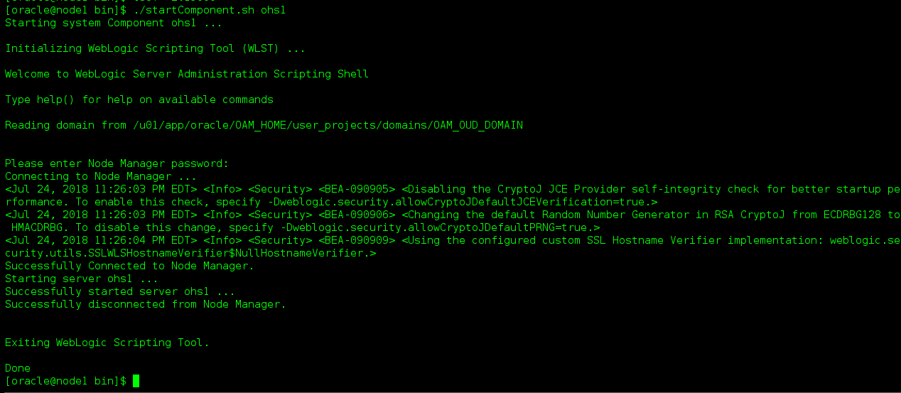

147.43.0.1:9999

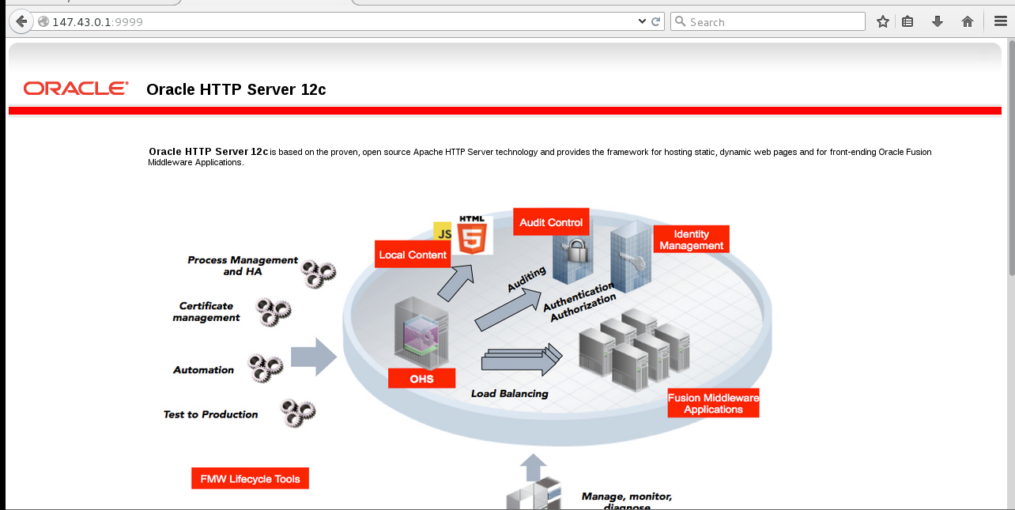

OUDSM

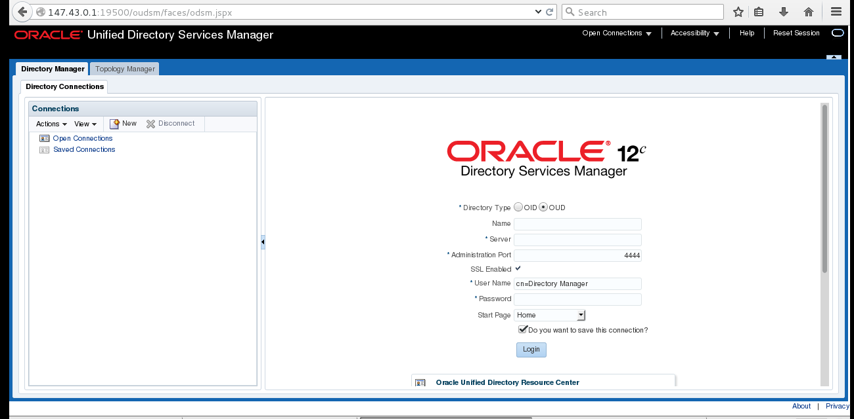

OUDSM was not launching as the OUDSM app was not targeted to Admin Server



How to Configure OUD

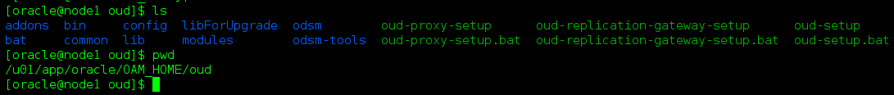

Launch OUD-Setup

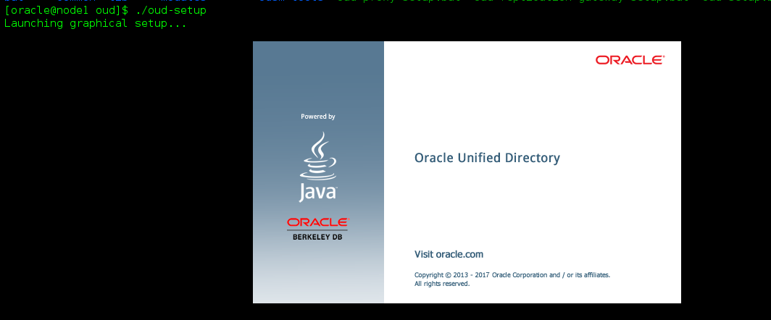

Next

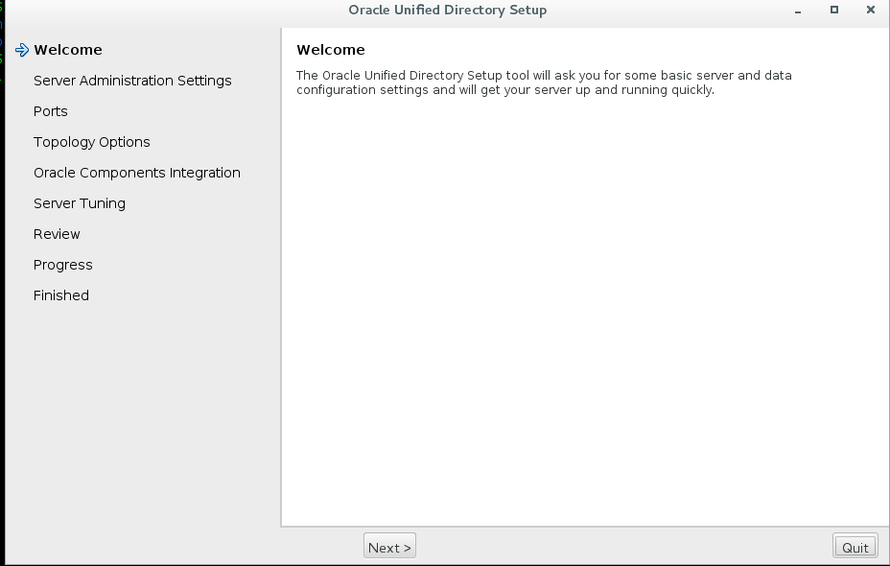

Server Admin Settings

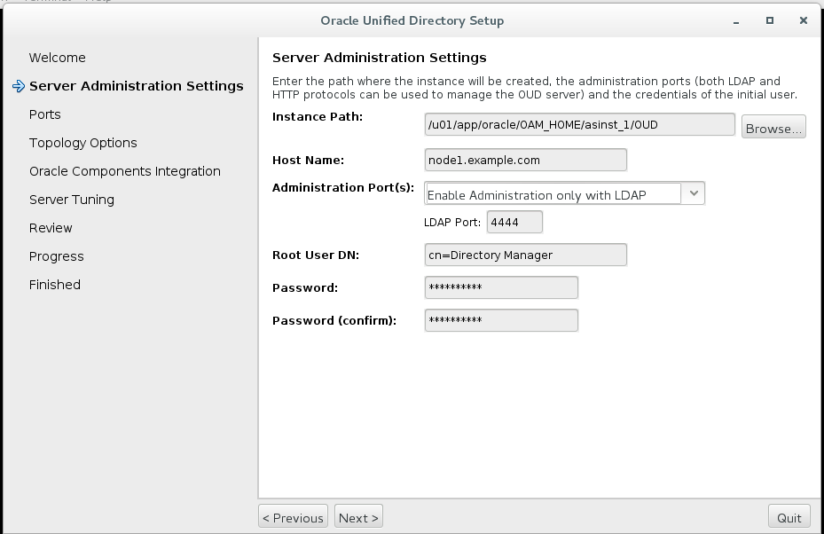

Ports

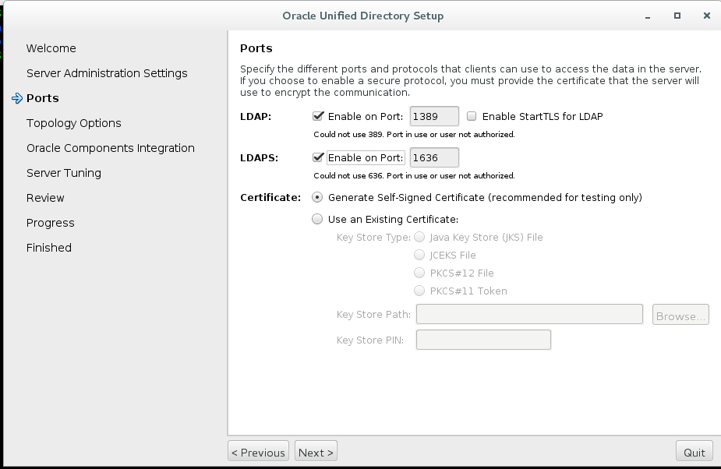

Standalone Server

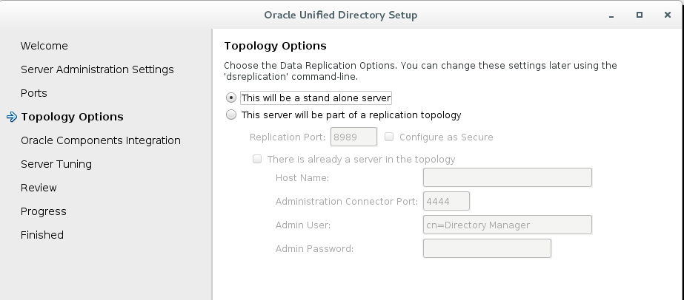

Leave Database empty

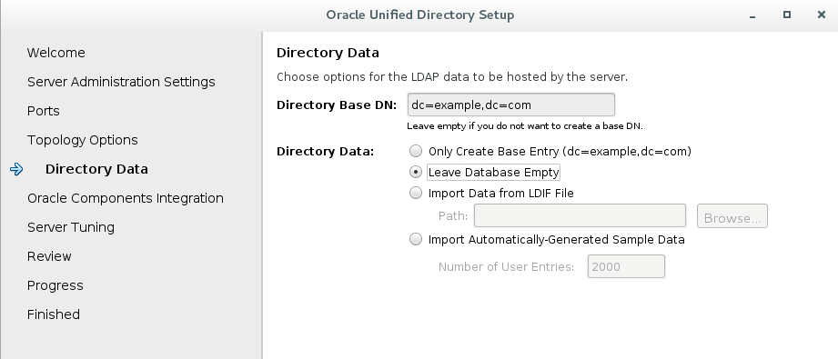

No Specific Integeration

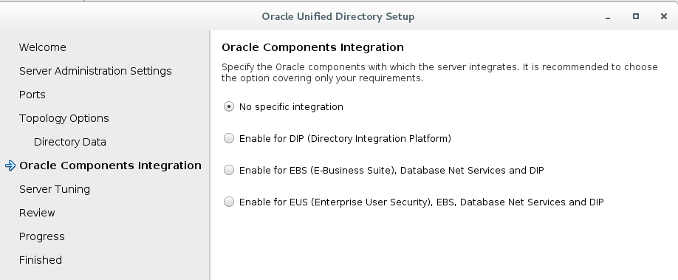

Memory

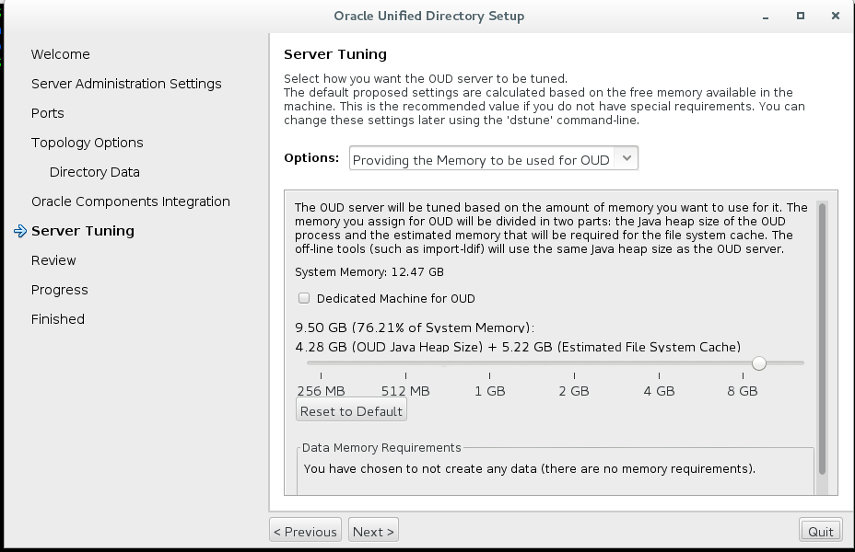

Run Time information

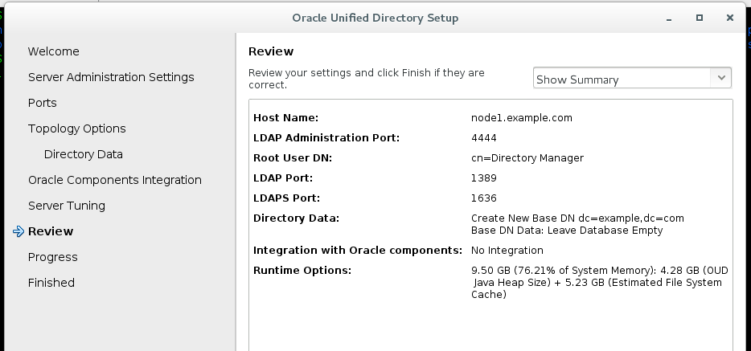

Summary

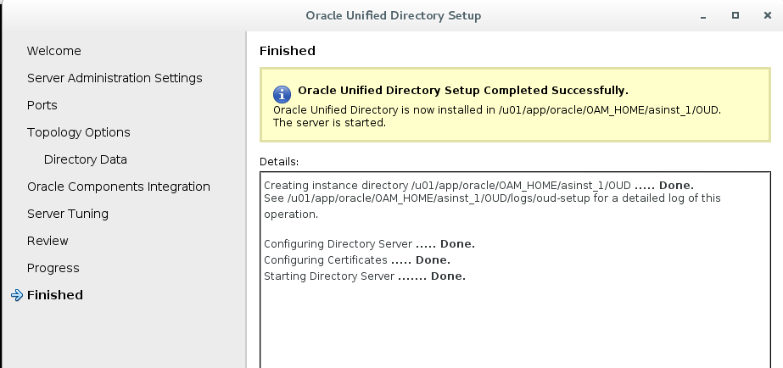

Stop Directory Server

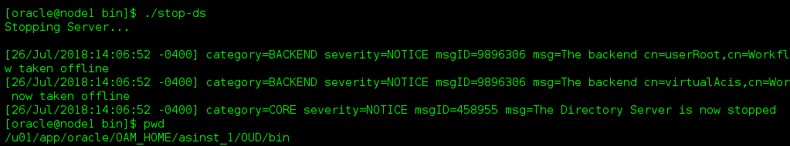

Start Directory Server

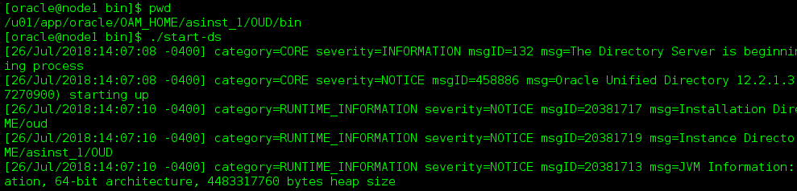

Check the status

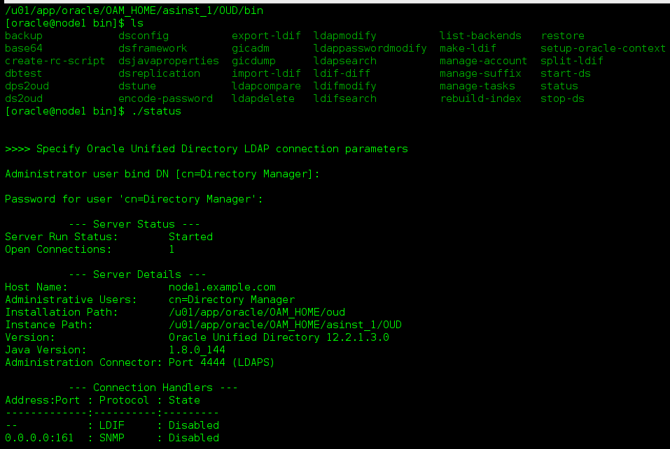

Logs for OUD



How to import Sample Data

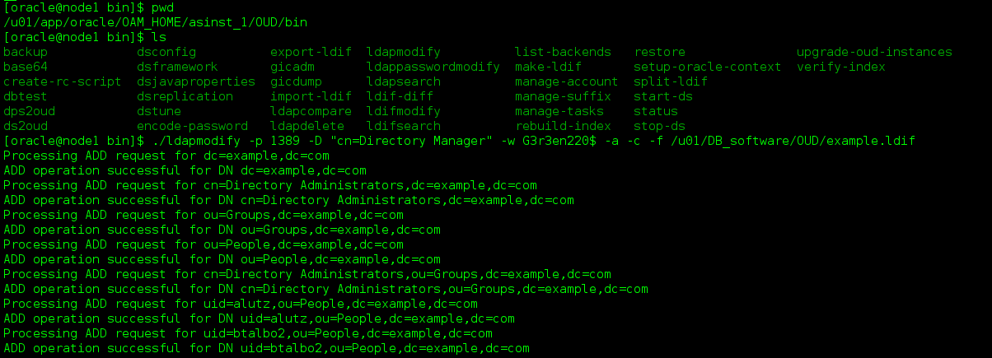

Login to OUDSM after starting Directory server

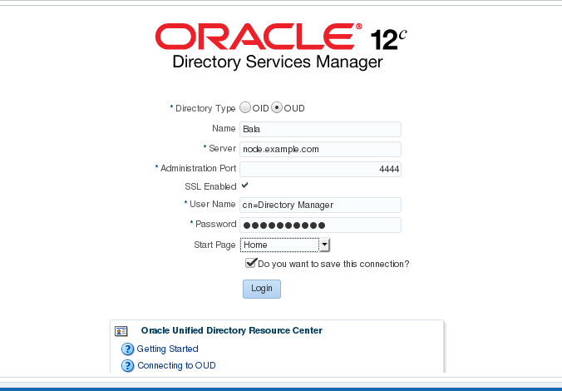

Welcome Page

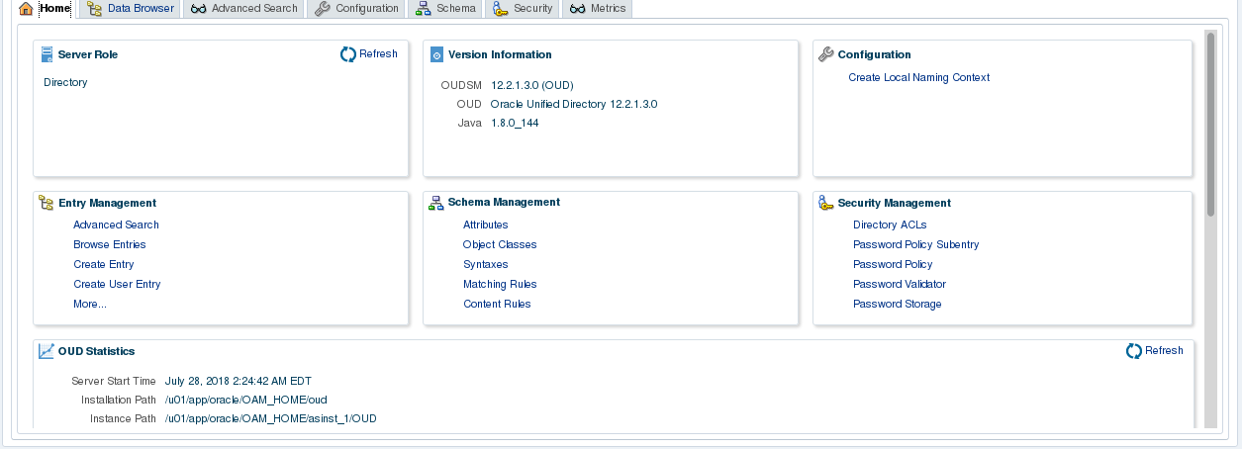

Configure OUD as the Identity Store in OAM

Go to configuration -> User Identity store

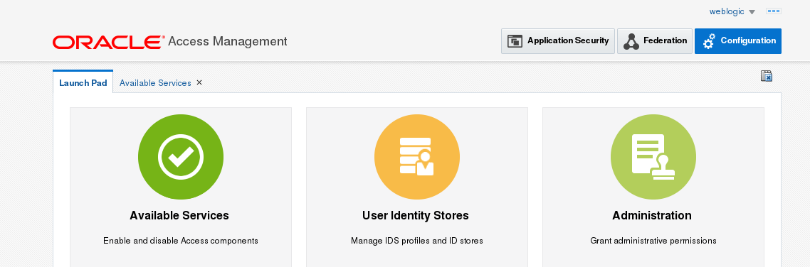

Click create in the OAM ID Store

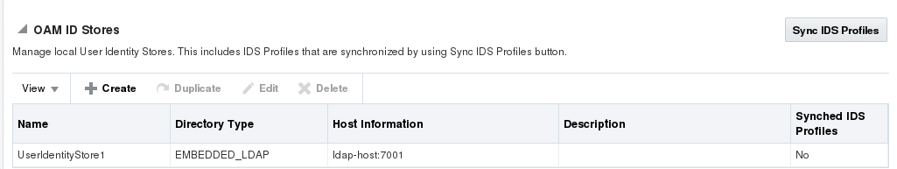

Fill the attributes

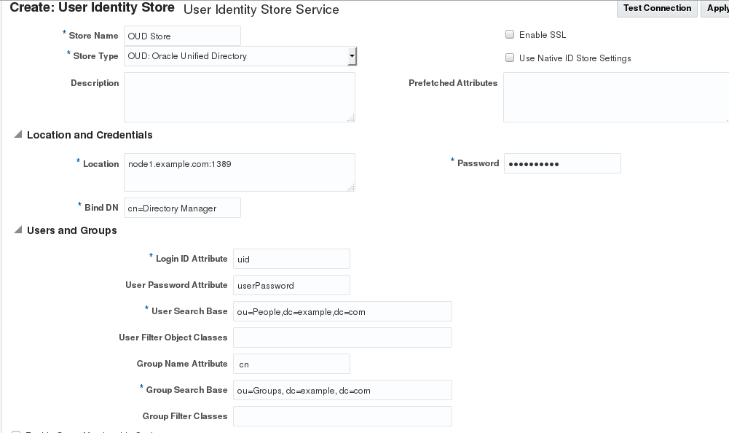

Click Test Connection

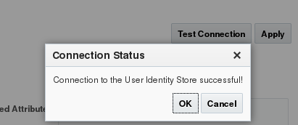

Confirmation

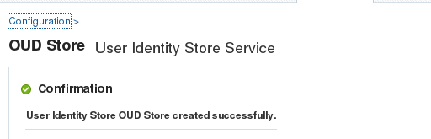

Access the User Identity Stores tab, and set Default Store to OUD_Store, and then Click Apply.

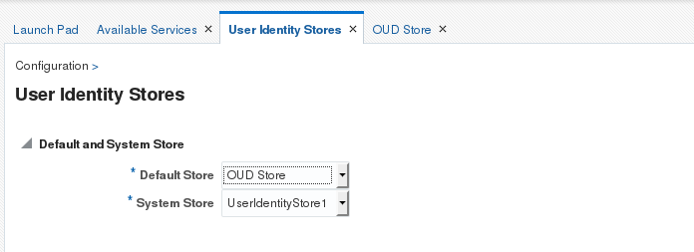

Click Application Security, and then Authentication Modules under the Plug-ins tile.

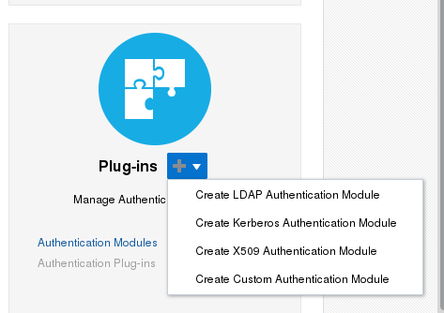

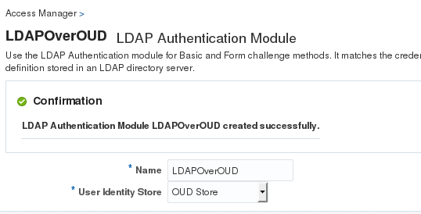

Click the Launch Pad tab, and click the Authentication Schemes link in the Access Manger tile. In the Search Authentication Schemes page, click Search. Select the LDAPScheme row in the search result and click Edit.  
In the LDAPScheme, click Duplicate. It creates a new scheme with the name 'Copy of LDAP Scheme'. Change this scheme as follows, and then click Apply.

* Name: LDAPOUDScheme
* Description: LDAP Scheme Over OUD
* Authentication Module: LDAPOverOUD

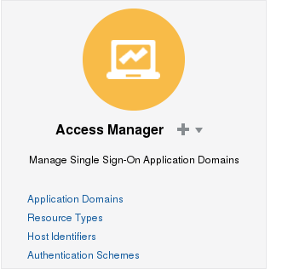

Click LDAP scheme and Edit

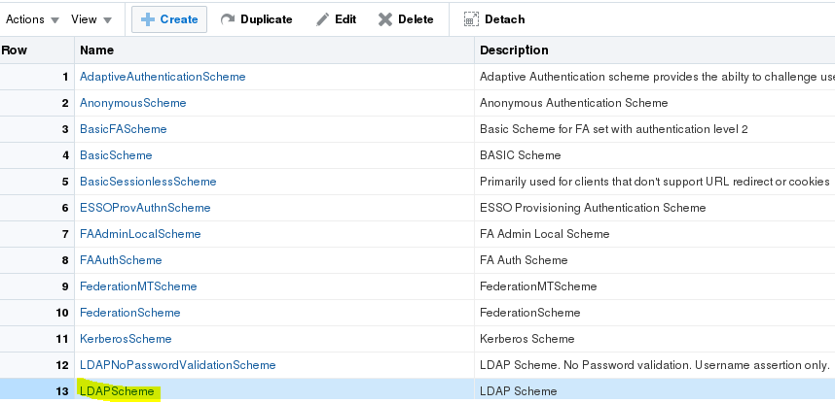

Click Duplicate

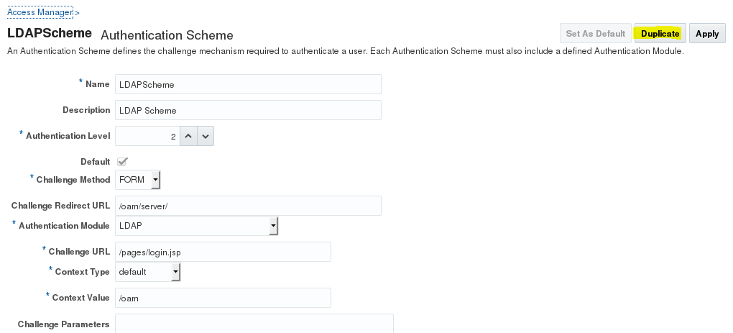

Change the scheme and set as default

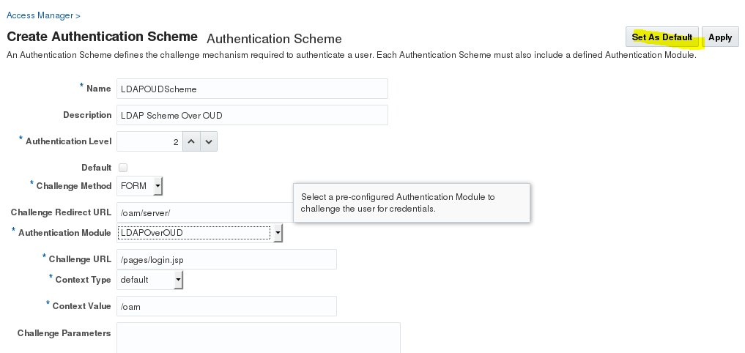

## Configure the Oracle Access Management WebGate

## Navigate to Webgate

## 

## Deploy the Webgate

## 

## Run the command

## 

## Before running the command (Webgate configuration file is missing in OHS)

## 

## After running the command (Webgate configuration file is present in OHS)

## 

## Run the following command

## 

## Output for the above command

## 

## We are running the above command , just to add webgate in OHS configuration

## 

## Register the WebGate with OAM

## 

## Click agent type Webgate and click Next

## 

Enter the Details and click Finish

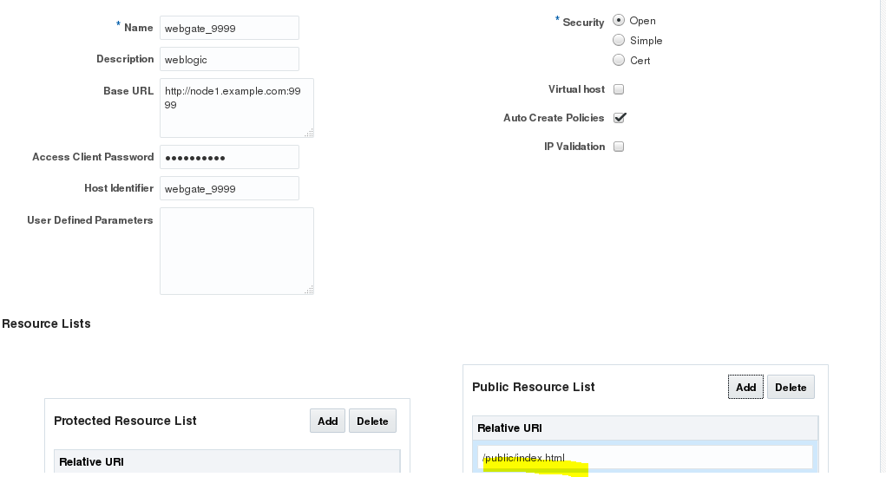

Download the File

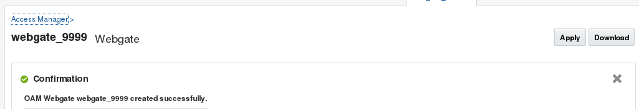

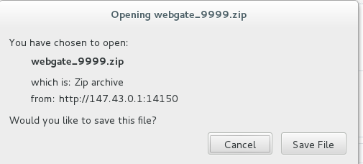

Move the Webgate file

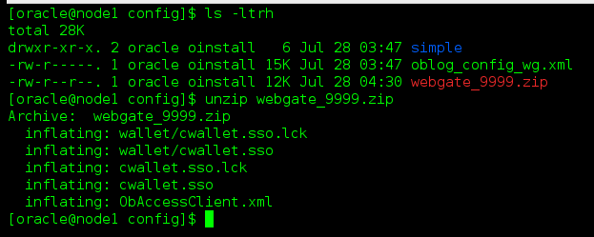

Restart the Servers

Now 147.43.0.1:9999 redirects to OAM SSO console

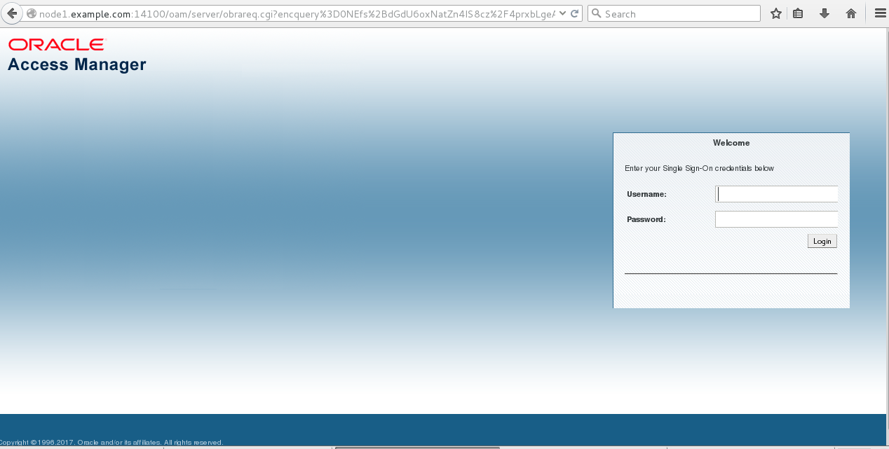

Enter your credentials and login , you will redirect to OHS server

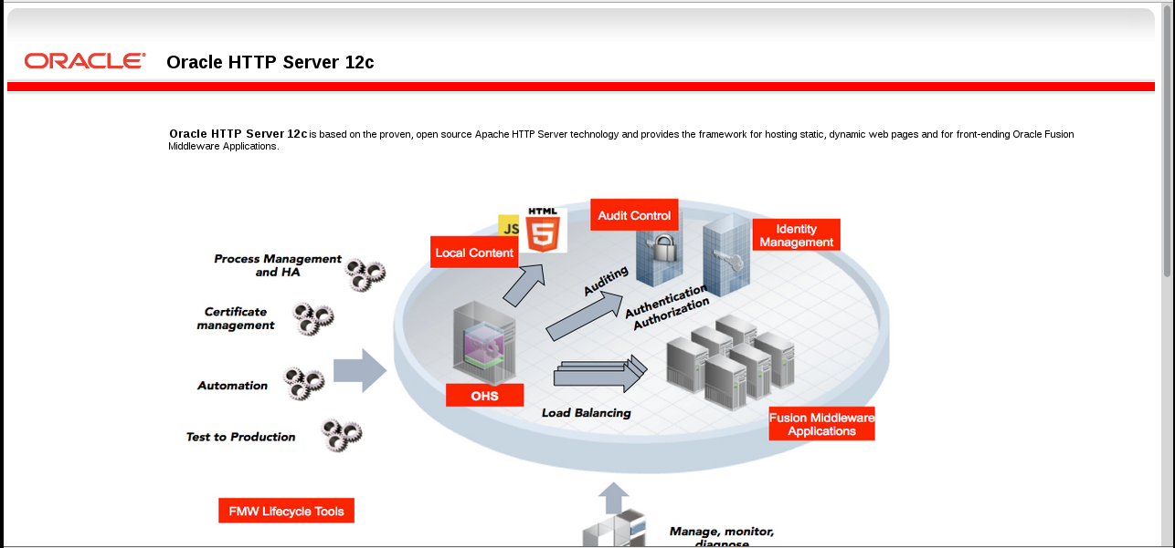

Webgate is protecting your application. Since OAM is registered with Webgate , you are getting OAM SSO page when you launch OHS server( 147.43.0.1:9999)

OHS🡪Webgate🡪OAM( Since webgate configuration is updated in OHS and Webgate is registered with OAM) thats why OAM SSO page

Protect the Application using Webgate

Deploy an application

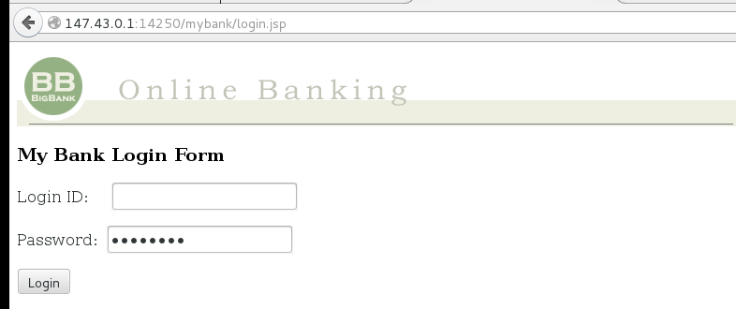

Instead of using MS port, the app must use Load Balancer port 9999

Log into EM and configure mod_wl_ohs

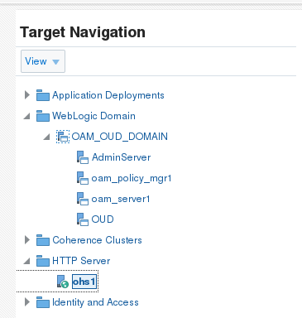

From the Oracle HTTP Server drop down menu select Administration > mod_wl_ohs Configuration.

Click the unlocked padlock icon in the top right of the page and select Lock and Edit.

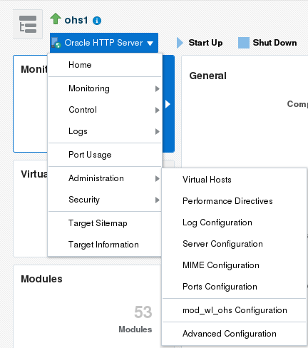

Enter web logic host and port details

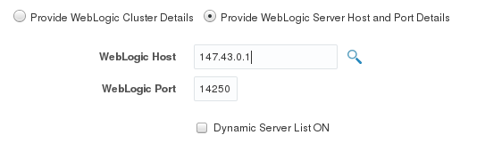

Location details

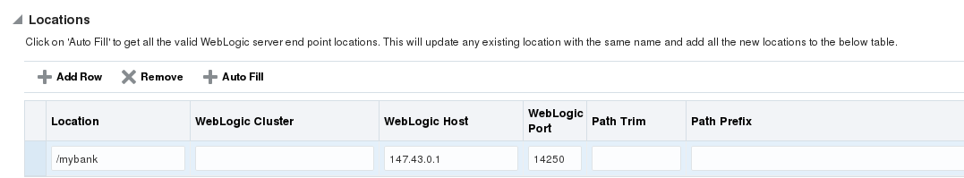

After applying, restart the OHS server

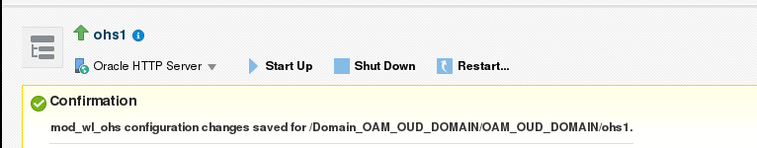

Now application is accessible via Load Balancer

**Note**: As all OHS pages are currently protected via Oracle Access Management, you should be redirected to the OAM SSO login page (notice that the redirect URL now points to OAM server 14100 port hosted on the OAM machine).

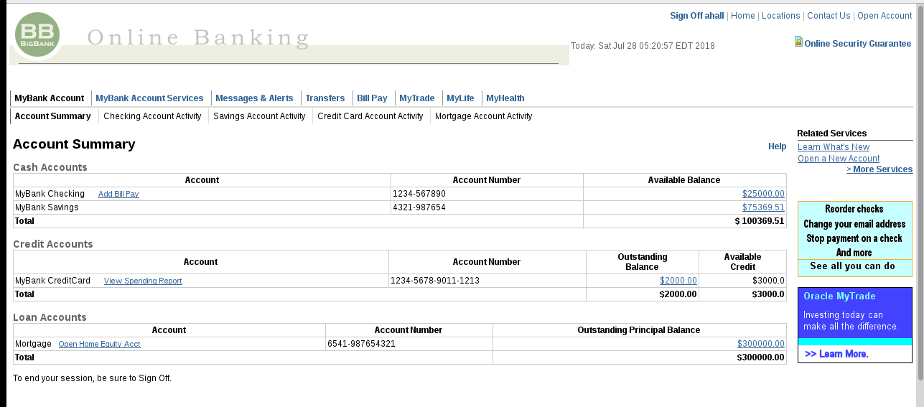

By default webgate protects all application that are accessible by OHS server( 147.43.0.1:9999)

Protect only mybank application

Login into OAM Console

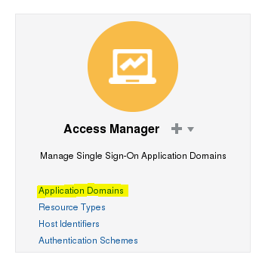

Click Webgate

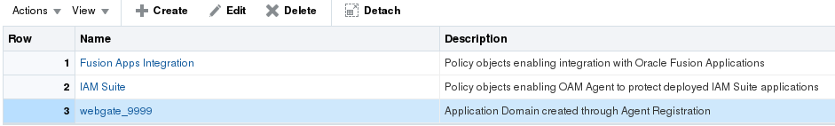

Then Resources

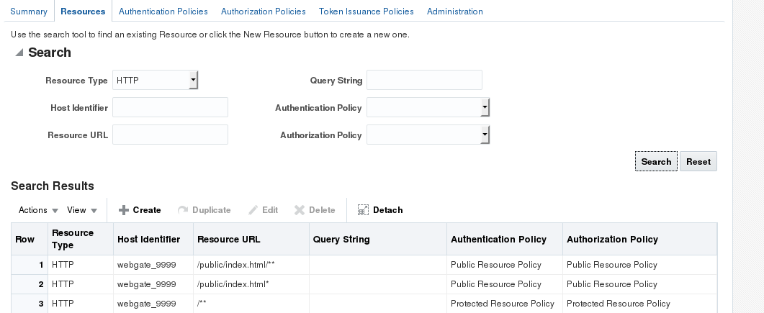

1. Under **Protection**, set **Protection Level** to **Excluded**. Click **Apply**.
2. On the **Resources** tab select the Resource URL **/\*\*** and click **Edit**. Change **Protection Level** to **Excluded** and then click **Apply**. Changing Protection Level to Excluded means that all URL's under http://oam.example.com:7777are now unprotected.
3. Close the current tabs to return to the **webgate_7777**Resources tab.
4. Set up a policy to protect the mybank application /mybank, by clicking **Create**. Create the /mybank resource as follows and click **Apply**:

Set up a policy to protect the mybank application /mybank, by clicking **Create**. Create the /mybank resource as follows and click **Apply**:

|  |  |
| --- | --- |
| **Name** | **Value** |
| Type | HTTP |
| Description | mybank application |
| Host Identifier | webgate_7777 |
| Resource URL | /mybank |
| Protection Level | Protected |
| Authentication Policy | Protected Resource Policy |
| Authorization Policy | Protected Resource Policy |

Create Resource to Protect Mybank app alone

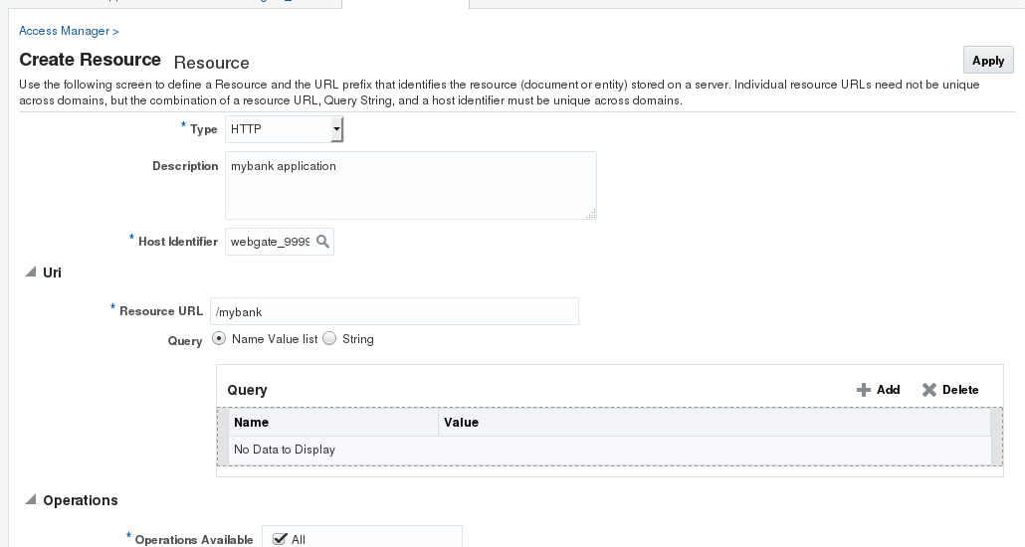

And mybank is accessible

